Project Architecture

(Sample Architecture Diagram)

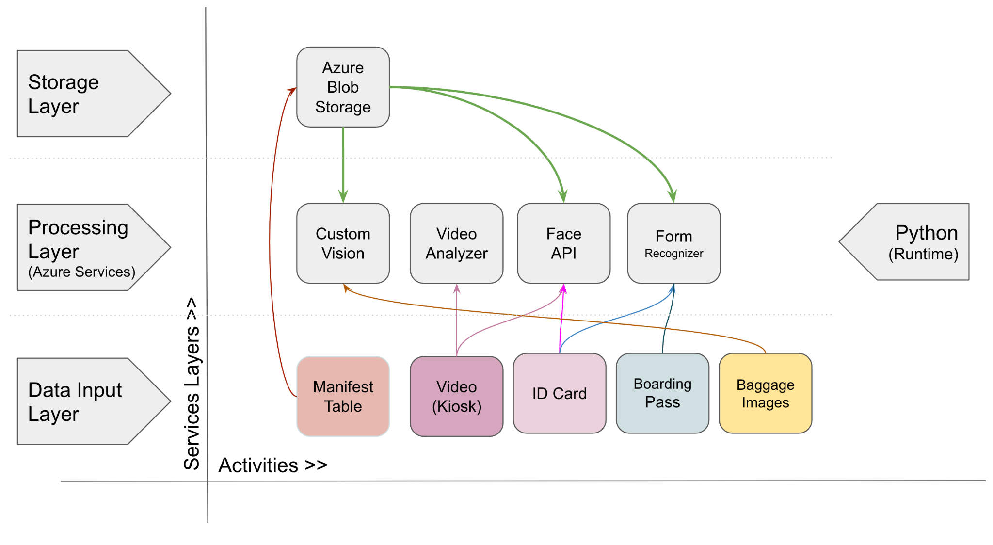

**Guideline to create the Architecture Diagram:**

* Identify the services you will be using and categorize them into storage, processing, input, output, execution layers
* Select all the activities your application will perform
* Now you can create a graph where on X axis you can have all activities and on Y axis you can have all the layers in their proper order
* Choice of keeping content on X and Y axis is your choice
* Now display all the content you identify in their specific layer

**How to follow the Guideline as shown in above example:**

* We have several activities and components in our project as Manifest Table, Id card, Video, boarding pass and baggage images
* We are using Azure Vision services as Custom Vision, Form Recognizer, Face API, Video analyzer
* We store all of our data at the Azure Blob Storage
* Based on the above collections, we create 3 layers as storage, processing and input for our architecture.
* We place proper content to Blob storage to the storage layer
* We place all the Azure services into the Processing layer
* We place all the inputs at the data input place.
* Now we need to connect these components together based on their interaction inside the project.

**Objective:**

Our objective is that looking at the architecture diagram, the reader should be able to understand various services and components that interact in our project.